**WanderPaw User Manual**

Welcome to WanderPaw!

Congratulations on choosing WanderPaw, the perfect app to find and adopt your new furry friend. This user manual will guide you through the process of using WanderPaw and help you make the most of your pet adoption journey.

**Table of Contents**

1. **Introduction**

- What is WanderPaw?

- Features and Benefits

**2. Getting Started**

- Creating an Account

- Setting Up Your Profile

**3. Browsing Pets**

- Finding Pets Available for Adoption

- Viewing Pet Profiles

**4. Adopting a Pet**

- Contacting Pet Owners

**5. Adding a Pet for Adoption**

- Creating a Pet Profile

- Uploading Photos

- Providing Pet Details

6. **Account Management**

- Editing Your Profile

1. **Introduction**

**What is WanderPaw?** WanderPaw is a mobile application designed to connect pet owners with potential pet adopters. Our goal is to facilitate the process of pet adoption by providing a user-friendly platform to browse, communicate, and finalize the adoption process.

**Features and Benefits**

-Easy Pet Browsing: Browse through a wide selection of pets available for adoption with just a few taps.

- Comprehensive Pet Profiles: View detailed pet profiles with photos, and descriptions.

**2. Getting Started**

**Creating an Account**

Once you have installed WanderPaw, open the app and create an account:

1. Click on "Log In" or "Sign Up."

1. Provide your email address or use your google account to sign up.

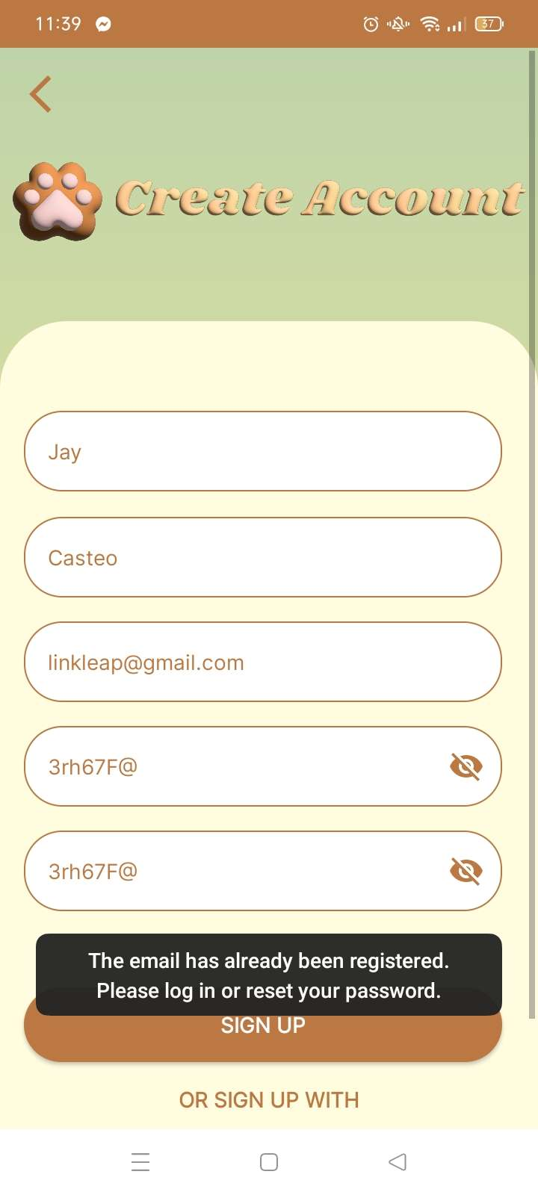

1. Choose a strong password and verify your account through the email or phone verification process.

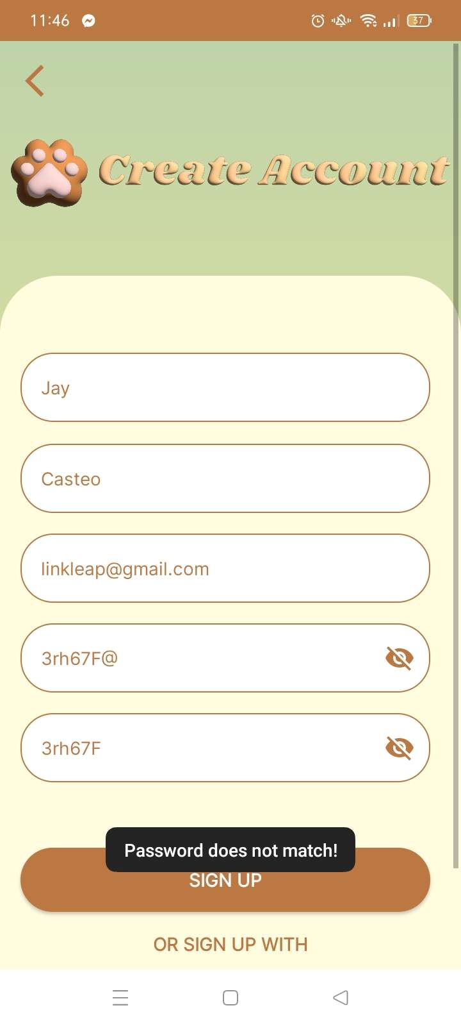

**Setting Up Your Profile**

Completing your profile will increase your chances of finding the perfect match:

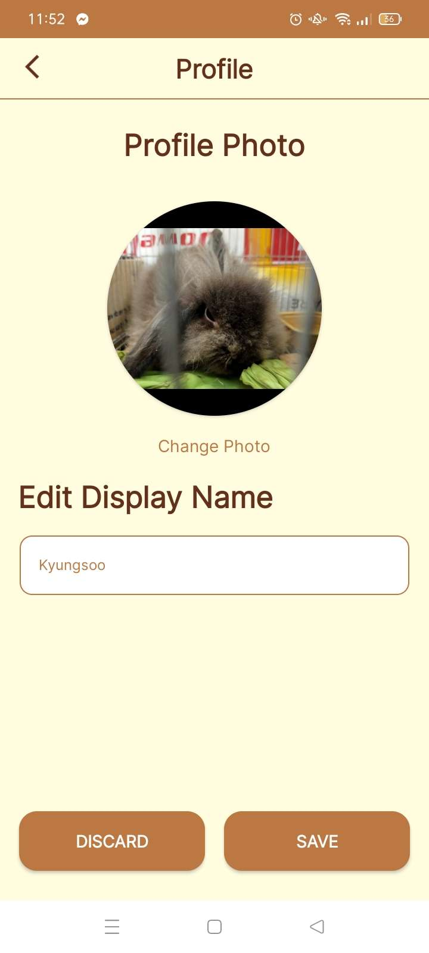

1. Upload a profile picture.

2. Edit your display name.

**3. Browsing Pets**

**Finding Pets Available for Adoption**

1. After Log In you will be Directed to Pet List.

2. Scroll through the list of available pets.

**Viewing Pet Profiles**

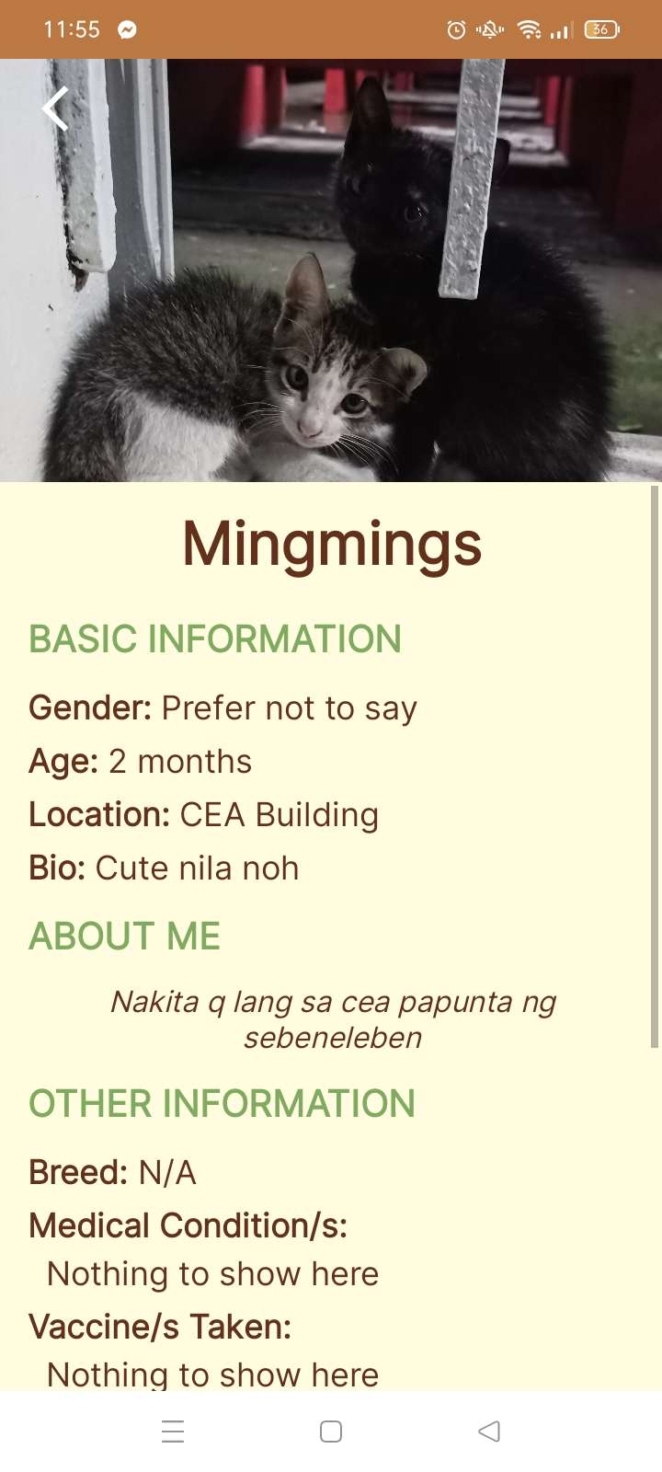

1. Tap on a pet's profile to view detailed information about them.

2. Explore their photos, videos, and descriptions.

**4. Adopting a Pet**

**Contacting Pet Owners**

1. To express interest in adopting a pet, use the Contact Information in Pet Profile to contact the pet owner.

2. Use the Contact Information to talk about adoption on the pet you’re interested.

**5. Adding a Pet for Adoption**

**Creating a Pet Profile**

1. Click on "Add Pet" in the app's navigation button.

2. Fill in the required information about the pet, including name, age, breed, and location.

3. Upload clear and appealing photos.

**Uploading Photos and Videos**

1. Capture or choose high-quality photos of the pet.

2. Make sure the media represents the pet's personality and appearance accurately.

**Providing Pet Details**

1. Write a compelling description of the pet's personality, habits, and care requirements.

2. Mention any health issues or special needs if applicable.

**8. Account Management**

**Editing Your Profile**

1. To edit your profile, go to the "Profile" section of the app.

2. Click on the "Edit Profile" button and make the desired changes.

